https://elearningevolve.com/blog/learndash-developers/

Looking for LearnDash Developers? Your Search Ends Here!
Are you looking for a LearnDash developer for your WordPress LMS project?
Let us help you find the best one because it’s tricky to effectively utilize a plugin and handle the technical issues that popup from time to time. However, this doesn’t make you any less of an expert in your field. As a LearnDash developer myself I understand the troubles many non-technical WordPress website owners face when it comes to plugin development and customization.

Why Do I Need a LearnDash developer?
This is a fair question. Why would you need to hire a LearnDash developer to take care of your LMS website? The answer simply put, because you need to have maximum functionality with an excellent user experience for both yourself as an admin and the user. As a result, the default functionality and features don’t fulfill the needs, and you might want to look for LearnDash development and customization service.
If you are someone who doesn’t want to pull your hair out while trying to figure out how to add a certain function to your LearnDash, we have brought together here the list of finest LearnDash developers and agencies for you to choose from.

List of LearnDash consultants
We’ve created a list of handpicked LearnDash consultants based on positive reviews from the most popular and vibrant community group on Facebook, LearnDash LMS Tips & Tricks Here we go:

Ryk Melck

Ryk is one of the top-rated geniuses in the LearnDash community group. He has already helped tons of people in the LearnDash community through his knowledge, problem solving skills and moreover his dedication and excellent customer service. People simply love him for his help and here is what they say about him in the community group.
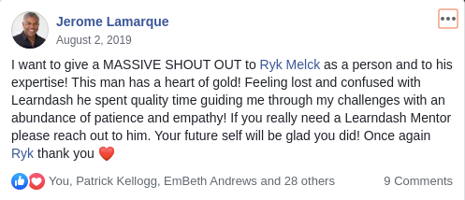 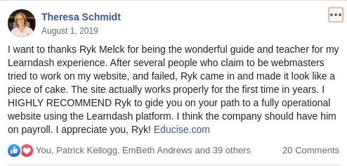
You can reach him through his site here or on Facebook: Ryk Melck and LinkedIn Ryk Melck

David Glow

Another coffee lover on the list. David has a vast experience of working on learning strategies, and all things learning-related. He is passionate about deriving zero-cost learning solutions. He is working with the Human Performance Institute as a Learning Technology Specialist. Follow him on twitter: David Glow, Facebook: David Glow and LinkedIn David Glow.

Dennis Hall

Dennis is a seasoned LMS planner and developer with many plugins that fix or add custom functionality to LMS plugins. He is passionate about helping organizations improve performance through Learning System Technologies. He is the founder of Learning Templates. To follow him for his great insight on learning technologies, Twitter: Dennis Hall, Facebook: Dennis Hall and LinkedIn Dennis Hall.

Dave Warfel

Dave is an exciting combo with his passion for hiking, fitness, nutrition, writing, and development in no particular order. He is a minimalist trying to save the planet. Dave loves writing and can be found on Dave Warfel (Twitter). He is the owner of Escape Creative, where he focuses on helping people build function websites, and is very active on Twitter: EscapeCreative. However, he also runs a WP blog WPSmackdown with regular tweets at wpsmackdown. Reach him at Dave Warfel on Facebook and LinkedIn Dave Warfel.

Patrick Kellogg

Patrick is our video guy, a senior web developer, chef, and a pioneer in mpeg videos and the author of H5P for LearnDash his passion for LearnDash development combined with his love for videos is evident from his Youtube channel where he puts up tutorials. He has recoived tons of positive reviews from the LearnDash LMS group and is one of the most active members and can be found on Facebook at Patrick Kellogg, and Twitter: Patrick Kellogg.
Be sure to check out his Youtube channel at Patrick Kellogg.

Adeel Raza
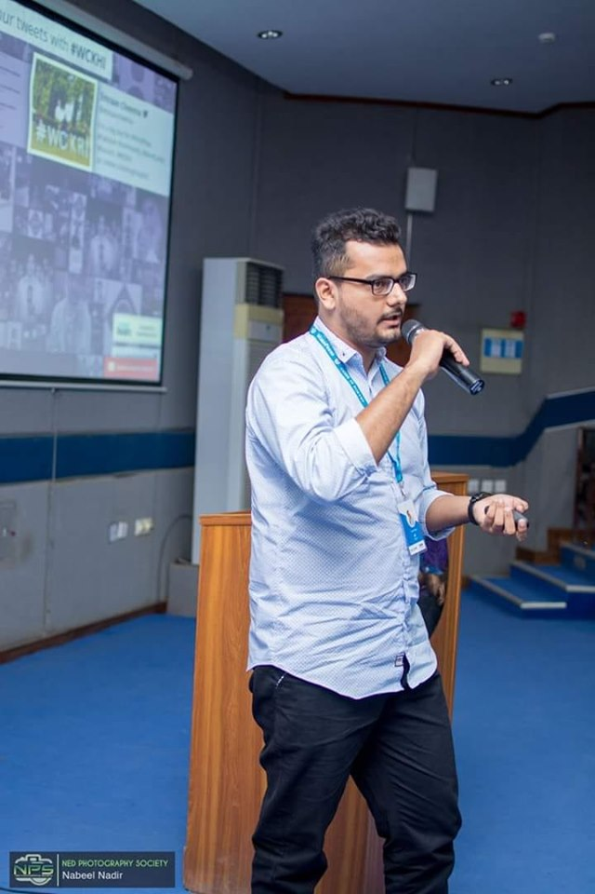
Speaker WordCamp2019 in Karachi
I am a passionate LearnDash LMS developer with extensive knowledge and experience working with custom LearnDash development. I’ve proven my love for LearnDash with some useful contributions to the LMS community via Adaptive Learning with LearnDash, myCRED LearnDash Integration addon, and a fairly recent one LeanrDash Student Voice. You can check my recommendations here. Reach me out through the contact page here or Facebook at Adeel Raza, LinkedIn at Adeel Raza.

Ellen Martin

Ellen is another prominent name for LearnDash customization help, she aims to help experts and entrepreneurs to launch transformative courses with her CourseLauncher Platform. She has received great reviews from the LearnDash community and can be a reliable expert for your LearnDash project. You can reach out to her on Facebook

Top 4 LearnDash Agencies
If you are looking for an agency that specializes in LearnDash then here is our list of the top 4 agencies for LearnDash development and customization service.

Uncanny Owl
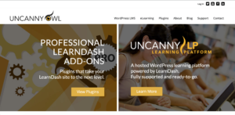
Uncanny Owl is recognized as one of the top LearnDash Customization experts. Their plugin, the Uncanny LearnDash Toolkit, is recognized by LearnDash. If you want the best people to work for your project, contact them here.

Codeable
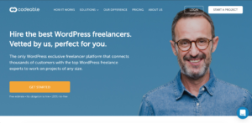
If you’re looking for a reliable platform to hire your next WP expert, Codeable is the place. Since they only hire the top 2% of the WP experts, you’ll be in safe hands. Email them for your queries or visit their website to get started.

LMS Ninjas
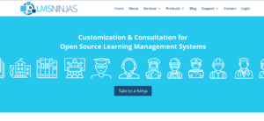
LMS Ninjas are the true ninjas of learning management systems. They have developed many add-ons, and have worked on various LMS platforms. To get a ninja to help you with your development or gamification project, contact them here.

WISDMLABS
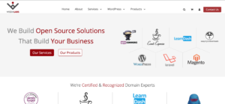
WisdmLabs are pros at plugin development and customization. They have a no.of popular LearnDash add-ons on their name and also the popular eLumine LearnDash theme. You can contact them here.

WPExperts.io
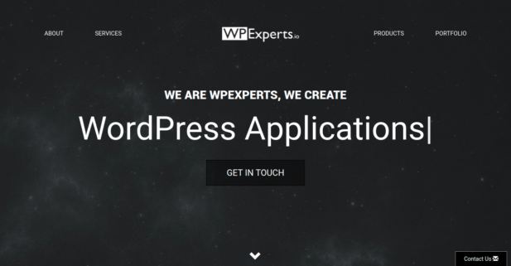
WPExperts is also a well known name. They provide a variety of WordPress development services and it also includes LearnDash development. You can reach out to them here for more details

The Bottom Line
In conclusion, if you are struggling with your online courses because of custom functionality or user experience issues with LearnDash, it’s time you get some help. All of the LearnDash experts are top among the industry. Moreover, you can also get in touch with us for reliable LearnDash development and customization services. Happy teaching!

We recommend LearnDash LMS, Uncanny Plugins, BuddyBoss theme & App

